**ECEN4730 Golden Arduino Report**

**Chengming Li**

**11/18/2022**

1. **Section I Design Review**

* **Schematic And Layout Design**

Schematic

Layout

* **POR and Risk Reduction**

Since there are multiple places where we need to measure the correctness of the board and reduction of inductance, two extra GND headers are included in the design and near the pinout of Atmega328. In addition, some test points for power rail are included in the design as well. Red LEDs are included in the design to verify the liveness of the Board and functionality of TX and RX pins. To better reduce the switching noise of ICs, decoupling capacitors are placed near the Vdd pin of ICs.

* **What did you do that did not work well- hard errors that were fixed or software errors?**

At the beginning of the test, the board can be boot loaded, but the code can’t be uploaded to the board. The reason is that the incorrect crystal is used near the CH340g. A 12MHz crystal is supposed to be used in the design of CH340g, but the 16MHz crystal was being used. Thus, the computer can’t recognize the COM port. This hard error is identified and fixed by replacing it with an SMT 12MHz crystal.

The soft errors in my design are too many cross-under being used. This error affects the performance of switching noise reduction. And two long cross-under are being used, which makes the performance worse than the commercial board.

* **What did you learn from this board design that you will do differently in your next design?**

Long cross-under is a lousy design technique in PCB design. Cross-under design makes the switching noise worse at the rising and falling edges. In my scenario, the long cross-under makes the performance worse, even if the decoupling capacitors are included. To make a better performance, short cross-under or no cross-under and decoupling capacitors must be applied.

Next time, I will be more careful to route the signal to avoid the cross-under included in the design.

1. **Section II Function of Board3**

* **Liveness of My board**

My board is boot loaded, and the blinking code is uploaded after the hard error(wrong crystal) is identified and fixed by replacing it with a 12MHz SMT crystal. Here is some evidence to show the liveness of my board.

12MHz Crystal Output

12MHz Output is measured from the Crystal near CH340g. This output proves that the computer can recognize the board. And there is communication between the computer and the CH340g chip

16MHz crystal Output

16MHz crystal output proves the chip is functional when the code is uploaded. The board is working as code expected if the clock is oscillating.

5V Output

5V output is measured at the 5V pin header.

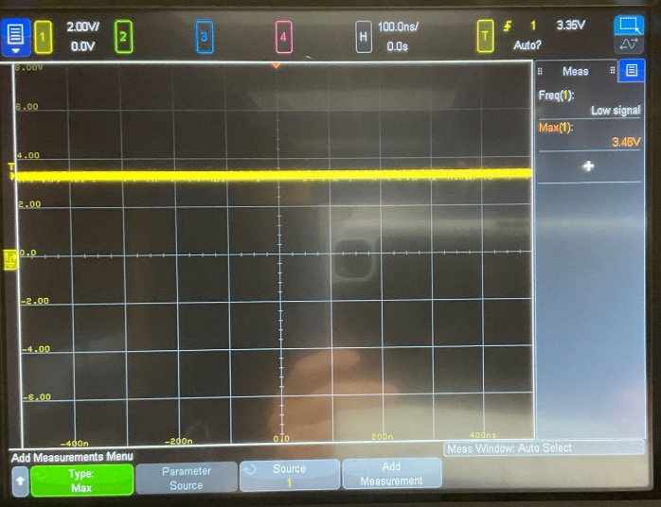3.3V Output

3.3V output is measured at the 3.3V pin header. It proves that the liveness of the LDO and voltage can be regulated down to 3.3V.

Activity of RX and TX

1. **Section III Performance of your board**

* **The switching noise and the quiet LOW pins**

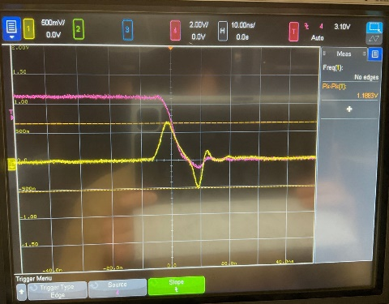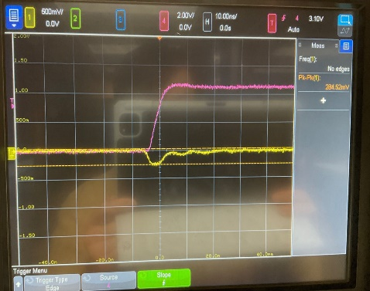

These two pictures show the switching noise in the QLOW pin at the rising and falling edge. 0.284 V switching noise has been found at the rising edge, and 1.18V switching noise has been found at the falling edge in the commercial Arduino Board.

These two pictures show the switching noise in the QLOW pin at the rising and falling edge. 0.25 V switching noise has been found at the rising edge, and 0.82V switching noise has been found at the falling edge in the custom Arduino Board.

The switching noise is improved in the custom Arduino Board by having decoupling capacitors near each IC. And since the QLOW pin stays low, the continuous ground contributes to the difference between the two boards.

* **the quiet HIGH and board-level power rail noise**

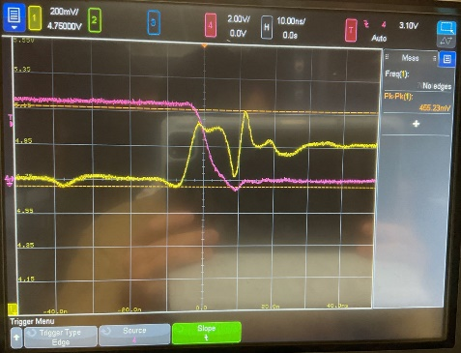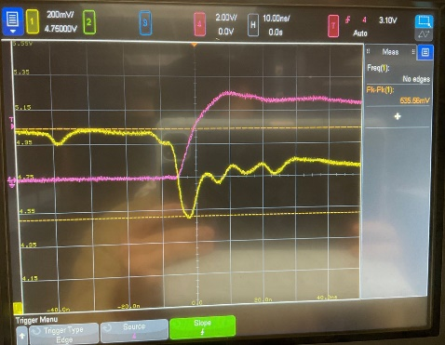

These two pictures show the switching noise in the QHIGH pin at the rising and falling edge. 0.53 V switching noise has been found at the rising edge, and 0.45V switching noise has been found at the falling edge in the commercial Arduino Board.

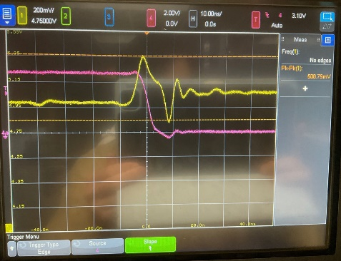

These two pictures show the switching noise in the QHIGH pin at the rising and falling edge. 0.355 V switching noise has been found at the rising edge, and 0.51V switching noise has been found at the falling edge in the commercial Arduino Board.

Compared to the performance between the commercial and custom Boards, the custom board has a better performance at the rising edge of QHIGH but a bit worse performance at the falling edge. It is because of the long trace from the Atmega328 chip to the Header. Long trace is referred to as larger inductance by the formula dV/dt = L*di/dt. The larger inductance will make the switching noise more significant.

* **the power rail noise on the board and the quiet HIGH pin when the slammer circuit is on**

These two pictures show the switching noise in the 5V Power rail at the rising and falling edge. 0.63 V switching noise has been found at the rising edge, and 0.66V switching noise has been found at the falling edge in the commercial Arduino Board.

These two pictures show the switching noise in the 5V Power rail at the rising and falling edge. 1.4 V switching noise has been found at the rising edge, and 2.78V switching noise has been found at the falling edge in the custom Arduino Board.

The custom board’s performance is way worse than the commercial board. I don’t have a decoupling capacitor near LDO, and I have a long trace from the power source to the header pins with a cross under. Long trace (large inductance) contributes to the harmful effects of switching noise reduction.

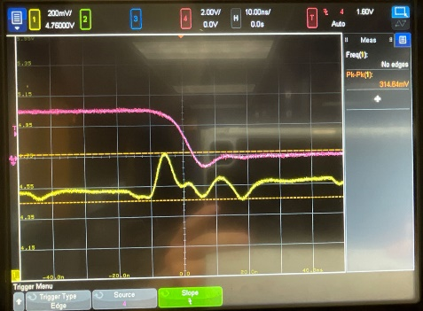

These two pictures show the switching noise in the QHIGH pin at the rising and falling edge when the slammer circuit is turned on. 0.48V switching noise has been found at the rising edge, and 0.31V switching noise has been found at the falling edge in the commercial Arduino Board.

These two pictures show the switching noise in the QHIGH pin at the rising and falling edge when the slammer circuit is turned on. 0.35V switching noise has been found at the rising edge, and 0.4V switching noise has been found at the falling edge in the custom Arduino Board.

The custom and the commercial board have roughly the same performance at either edge.

* **the near field emissions from under the board**

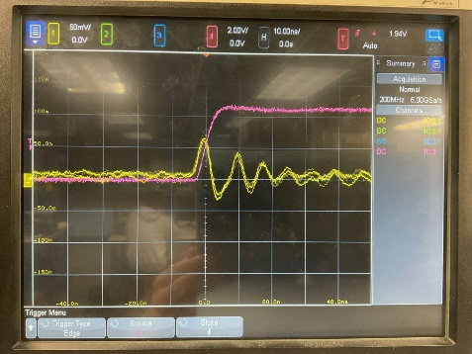

In the commercial board, there is roughly an 80mV switching noise.

In the custom board, there is roughly a 100mV switching noise.

The near field is a region with strong inductive and capacitive effects from the currents. This result is reasonable for my custom board since my custom board has a longer trace and long cross-under across the ground plane, which makes inductance and capacitance more significant than the commercial board. Thus, my custom board's near-field emission has worse performance than the commercial board.

Overall, in my next design, I will be more careful about including the cross under on the board. In addition, a shorter signal trace is also helpful to reduce the switching noise and improve the overall board’s performance. Last, including a decoupling capacitor near the Vdd of ICs, is essential in the PCB design.